**Setup** – **document**version 1

|  |  |  |  |  |  |
| --- | --- | --- | --- | --- | --- |
|  | Ground Matrix  Rachelsmolen 1, 5612MA, Eindhoven  Tel. 088 035 1011 |  |  |  |  |

**Company’s members:**Sander Dapperens,  
Mariya Adamova,  
Gintare Narbutaite

**Table of contents:**

Preface 3

Client 4

Processes 5

Functional requirements 7

Entrance / Exit to camping 8

Transaction application (buying and borrowing) 8

Website 9

User Interface 10

# 

# Preface

“Ground Matrix” is an IT company, which helps its customers to create offline and/or online environment to control their “business’’.  
 “Platonics” Music festival is a three day event, located in “Park Kuierpad”, which is the perfect area to organize such feasts. “Platonics” is going to be scheduled on the weekend. During those days, participants of the festival will be able to book a place in the camp for their tents (maximum 6 people). All the event members will not need credit cards or cash, if they want to buy something they have to use their “Platonics” participant bracelets.  
 This time “Ground Matrix” received a very unusual task, to deliver a package of website, several databases which are going to be connected with newly created applications for “Platonics” from its organizers.   
 The package will consist of website for the festival, application for entrance, database for user registration, database for event registration, application and database for entrance to camping, application for ability to lend some stuff (cameras, laptops, etc.) during the feast. We are also going to make a function for clients in the festival to be able to buy food and drinks by existing money in participant bracelets. Our company is also going to make a system for exiting the event. The person who exit the festival is going to be signed in the database and will not be able to enter festival territory again. The same type of database is going to be created for entrance. Ability to write feedback / share ideas and status during the event will be done as well.   
Three members of our company will do their best to successfully finish this project. For accomplishing this task we will need 224 hours in total.

# Client

Emin Thaqi is the owner and main organizer of the festival “Platonics”. He hired our company (Ground Matrix), to create some applications, databases and a website, that is going to help to control everything during this event. Mr.Thaqi works at “Fontys University of Applied sciences” in Eindhoven as a teacher.   
His contacts are:  
  
**Mr. Emin Thaqi,   
Email:** [**e.thaqi@fontys.nl**](mailto:e.thaqi@fontys.nl)**,  
Phone number: 08850-87002,  
Office: R1 2.37,  
Office address: Rachelsmolen 1,  
 Eindhoven, 5612MA,  
 The Netherlands**

# Processes

* **Enrolment** “Platonics” website provides all of the necessary information (time tables, prices for entrance, rent of the camping, artists and place) about the event, so that people who are interested can decide if they want to attend it or not.Over there people also have a possibility to buy tickets for this event. Everything is clearly explained (step-by-step), so to succeed in buying the tickets they need just to follow the instructions.   
  People who still wants to attend the festival, but did not buy the ticket online have another chance to buy a ticket at the entrance of “Platonics”. The only difference is that at the entrance the ticket is 10 euros more expensive than buying it online.Participants, who bought a ticket, but changed their mind and do not want to attend the event anymore, CAN NOT return the tickets back or get back their money.  
  Possibility to rent a camping spot is also provided on our website.
* **Payment**Immediately after user confirms the agreement of enrolment, he/she will be able to choose the payment method: PayPal, visa, visa electron.   
  Upon successful payment, person will be able to download the ticket (PDF) and the receipt of the transaction from the website. The same documents will be sent to his/her e-mail.   
  On the ticket will be participant details, amount of money that was payed and QR code.  
  Person whose payment was unsuccessful will be able to try it two more times (in total three times), otherwise he/she will still have a possibility to buy the ticket at the entrance.
* **The event**Checking – inThe participant must bring printed version of his/her ticket, with QR code and his/her personal details on it or to have the same document (ticket), on his/her smart phone or any other electronical device. After the ticked is checked at the entrance by one of the festival’s employees, an activated RFID bracelet will be given to each of participants. Those bracelets will be used during the event, for buying/lending stuff and exiting the festival. The QR code will no longer be needed unless a participant loses his/her festival bracelet.

On the festival  
Every participant of the event will be identified by their bracelets. They are going to be able to make transactions for their drinks, food, borrowing items, etc. It will be possible to charge those bracelets by using PayPal, visa or visa electron cards at the special machines which are going to be placed during the event.

Exiting the fest  
For exiting the event participants will need the bracelets again at the exit point, because then the user will be identified and his details will be stored into the database system. At the same time, it will be checked if a person has borrowed an item e.g. A camera, or a laptop, if so, he/she will not be allowed to leave the event until the issue is solved. For people who has returned everything and does not have any outstanding bills e.g. For food or drinks or other services, will be able to leave after handing in the bracelets which are going to be deactivated.  
Every participant must use entering and exiting points, so that this system would work successfully.

|  |  |  |  |  |  |  |  |  |
| --- | --- | --- | --- | --- | --- | --- | --- | --- |
|  |  |  |  |  | Must | Should | Could | Would not |
| Entrance / Exit event applications | | | | |  |  |  |  |
| Be connected to a database system | | | | | x |  |  |  |
| Keep track of entered / exited participants | | | | | x |  |  |  |
| Validate registration number | | | |  | x |  |  |  |
| Scan RFID when exiting | | |  |  | x |  |  |  |
| Check RFID for not returned items / left debts | | | | | x |  |  |  |
| Contain a real-time statistics | | | |  |  | x |  |  |
| Display the balance when entering/exiting | | | | |  | x |  |  |
| Display a number of entered participants on the screen | | | | |  |  | x |  |
| Display a details of participant when ticket is scanned | | | | |  |  |  | x |
|  | | | | |  |  |  |  |

# Functional requirements

An overview of all requirements for each application.

|  |  |  |  |  |  |  |  |
| --- | --- | --- | --- | --- | --- | --- | --- |
|  | | | |  |  |  |  |
|  | | | |  |  |  |  |
| Entrance / Exit to camping | | | |  |  |  |  |
| Display a number of booked camping spot on the screen | | | | x |  |  |  |
| Display price if buying camping spot | | | | x |  |  |  |
| The number of RFID must be validated | | | | x |  |  |  |
| The RFID number should be displayed | | | |  | x |  |  |
| The owner name of booked spot should be displayed | | | |  | x |  |  |
| Show the free spots on the map | | |  |  |  | x |  |
|  | | |  |  |  |  |  |
|  | | |  |  |  |  |  |
|  | | |  |  |  |  |  |
|  | | |  |  |  |  |  |
|  | | |  |  |  |  |  |
|  | | |  |  |  |  |  |
|  | | |  |  |  |  |  |
|  | | |  |  |  |  |  |
|  | | |  |  |  |  |  |
| Transaction application (buying and borrowing) | | | |  |  |  |  |
| Scan RFID |  |  |  | x |  |  |  |
| Display the price per item | | |  | x |  |  |  |
| Display the total price on the screen | | | | x |  |  |  |
| Show the balance that is left in your RFID | | | | x |  |  |  |
| Keep track of items in stock | | |  | x |  |  |  |
| Keep track of borrowed items | | |  | x |  |  |  |
| Display the pictures of available items | | | |  | x |  |  |
| Be able to display quantity of chosen item | | | |  | x |  |  |
| Be able to delete an item from the shopping cart | | | |  | x |  |  |
| To check balance before borrowing/buying an item | | | |  | x |  |  |
| Remove item that are no longer left in stock | | | |  |  | x |  |
| Keep track of amount of transactions per person | | | |  |  |  | x |
|  | | | |  |  |  |  |
|  | | | |  |  |  |  |
|  | | | |  |  |  |  |
| Website | | |  |  |  |  |  |
| Possibility to buy a ticket online | | |  | x |  |  |  |
| Provide information about the event | | | | x |  |  |  |
| Provide information about the location | | | | x |  |  |  |
| Provide map of the area | |  |  | x |  |  |  |
| Have user friendly design | |  |  | x |  |  |  |
| Possibility to register and/or login | | |  | x |  |  |  |
| Possibility to book a parking spot | | |  | x |  |  |  |
| Possibility to book a camping spot | | | | x |  |  |  |
| Give the news about the event | | |  |  | x |  |  |
| Show amount of tickets left | | |  |  |  | x |  |
| Show available camping spots | | |  |  |  | x |  |
| Provide a possibility to buy a parking spot | | | |  |  |  | x |
| Provide a possibility to buy VIP tickets | | | |  |  |  | x |

# User Interface

The main page of the application contains 7 buttons that are linked to the relevant application. All the applications are connected to a database.

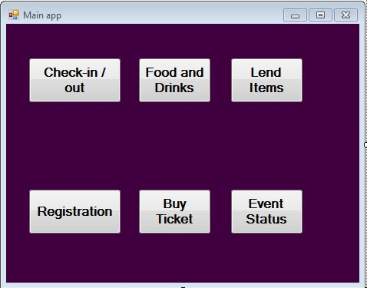The “Check-in / out” button is linked to a Check-in / out form which will be used by the visitors to enter and exit the event.

The “Food and Drinks” button is linked to Food and Drink form which will be used by the visitors to purchase items during the event such as food and drinks.

The “Lend Items” button is linked to Lend items form which will be used by the visitors to lend items they forgot during the event such as cameras, USBs, etc.

The “Registration” button is linked to the form which can be used by the visitors at the entrance of the event or at the website so then they can proceed to the buying ticket.

The “Buy Ticket” button is linked to the related form that the visitors can use at the entrance or at the webpage of the event there you can book a camping spot as well.

The “Event Status” button is linked to the related form that can be used only by the owner or the employees of the event.

## Check-in/out

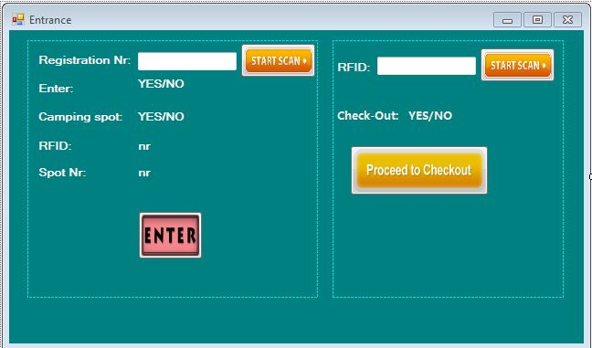The check-in/out tab of the application manages the checking in and out of the participants of the event.  
Once a user scans his/her registration number, the read-only text-box and labels will be filled in with the details of that user. The section for the camping spot will also be used at the entrance to the camping spot. A Boolean will appear when checking if the person is allowed to enter the event as well as the camping. If the participant has a booked spot, then the number of the spot should appear on the screen.

When checking out the user scans his/hers RFID chip and the Boolean will appear on the screen with YES for allowed to exit and NO for not allowed. Moreover, if on the screen is written NO a message box will appear with the details why the user cannot exit, i.e. he/she forgot to return one or more borrowed items.

## Event status

This application will be used by the organizer of the event for keeping track of the balance of the event as well as the participants who has checked in minus the one that have already checked out.

## Registration App

This app will be used on the event right before the entrance, it will be used by all the people who forgot to register online and buy a ticket. They need to fill their details and then proceed to buy a ticket.

## Buy ticket App

This app is for everyone who did not have the opportunity to buy ticket online. After making a registration the participant has to fill this form in order to buy a ticket. He/she is given the chance to book a camping spot as well, if available.

## 

## Store App

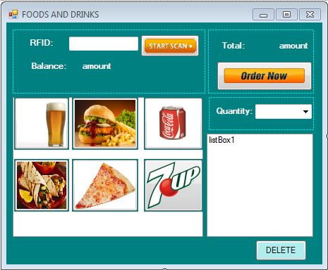This tab of the application is going to be used inside the event. Everyone who wants to buy something to eat or drink will first have to scan his/her RFID and then the balance is going to appear on the screen. The user can choose from a variety of products that are going to be displayed in a list-box with buttons and after clicking the button he may choose the quantity that he/she wants to buy. In another list-box will be displayed the already purchased items. If the customer wants to delete one or more of them he/she needs to click on the unwanted item from the purchased list of items and then click on the Delete button. The order total will be displayed on the screen and then all the user needs to do is to press is Order now button.

## Borrow App

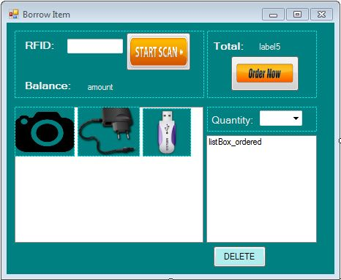This tab of the application is going to be used inside the event. Everyone who wants to lend something that he/she has forgot will first have to scan his/her RFID and then the balance is going to appear on the screen. The user can choose from a variety of products that are going to be displayed in a list-box with buttons and after clicking the button he may choose the quantity that he/she wants to lend. In another list-box will be displayed the already borrowed items. If the customer wants to delete one or more of them he/she needs to click on the unwanted item from the list of items and then click on the Delete button. The order total will be displayed on the screen and then all the user needs to do is to press is Order now button.